SKANDIAN HISTORY
  - REBIRTH OF ARCADIA (ERA 6)

Table of Contents
Arcadia City 1
Organized Plotting 1
Arcadian Capitalism 3
Security Complex 4
Foreign Investments 5
Unity Tower 6
Foreign Conflicts 7
LoneWolves & Arcadia 7
Pentagram Conflict 8
Enemies Combined 9
Lonewolves Strikes 10
End of Conflict 11
Rebirth of Arcadia 12
Araluen 12
Return to Skandian Dominance 13
Arcadian Council Reformation 13
Phoenix 14
The Hacker that Killed it All 15

Arcadia City

Organized Plotting
Era 6 lasted a total of 45 days, and during that time Arcadia built what was likely its grandest city since Era3. It was organized with the largest skyscrapers in the middle and the homes on the outside, not necessarily symmetrical, but it was organized plotting. Similarly the zone for the highest skyscrapers extended 5blocks higher than the housing district so that the city would look stacked. For the most part, this system worked, but because so many plots were dedicated to being skyscrapers of such large sizes, many of them were never filled and thus the project failed to look as it was supposed to when completed.
Regardless, to look at this as a failure would indeed be a false statement, for it is true that the city never filled as expected, but it also set the baseplate for future cities to be more organized and to match the needs of those wishing for an industrial Skandia and a rural Skandia. It would not be until Era8 however, that such a split would occur entirely with both living in different sections of Arcadia. Organized plotting similarly allowed for people to own individual plots whether in Arcadia or not, and served to divide Arcadia’s capitalist market from its individual home owners. Similarly, by bringing several of Skandia’s major ‘companies’ close together it allowed for trade between the two & for more competition, something vital towards building the center of Arcadia.
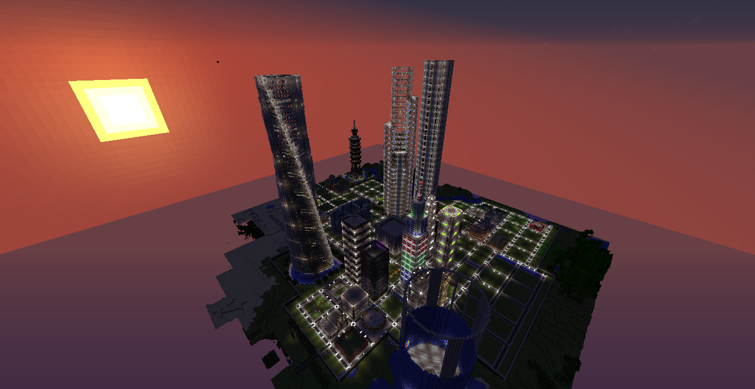
It should be noted that Arcadia City is the capital of Arcadia, and is open to all citizens of Arcadia, but is the home-city of Skandia as well.

Arcadian Capitalism
As mentioned above, Arcadia had a fairly large capitalist market. This first arose in Era3 during Skandia’s war with Malahostias which led to the creation of Arcadia, See http://arcadiamc.weebly.com/history.html. During the war Skandia saw the need to mass produce armor, weapons, and ultimately, WoMDs (Weapons of Mass Destructions). It is estimated that at its height Skandia had a total of 5,800+ Nuclear Reactors and over 13,000 Uranium Cells. Most of the materials however cost a large amount of EMC to produce, and seeing as Skandia’s government relied entirely on donations for its EMC, this presented a problem, especially with the Nuclear Reactors.
The fix to this was to create a capitalist market inside Skandia which led to the creation of companies like FartCo, owned by Loyd_Kun (I deserve the right to brag about remembering that after not seeing him in 8months), BosCo, owned by TheBosnianGamer [Now _Bosnian], and Skandia’s government itself. Whichever company was willing to produce the materials at the cheapest price won the contract to provide it for Skandia’s government. Ultimately, this meant that the overall EMC Cost was generally far less than it was to actually produce the items.
This capitalist market continued throughout Era4 with the creation of Arcadia, strengthened in Era5 where there was no EE2 on Voltz, and continued in full force into Era6 with new companies like BobCo and Independent companies rising as well. These markets were the driving force in producing items that couldn’t be EMC’d for Skandia. Each capitalist market was required to build a skyscraper on a 40x40 plot in the center of Skandia which kept them close together, the lag away from the outer rim of the city, and made it so that these businesses required work behind them instead of simply being a name.
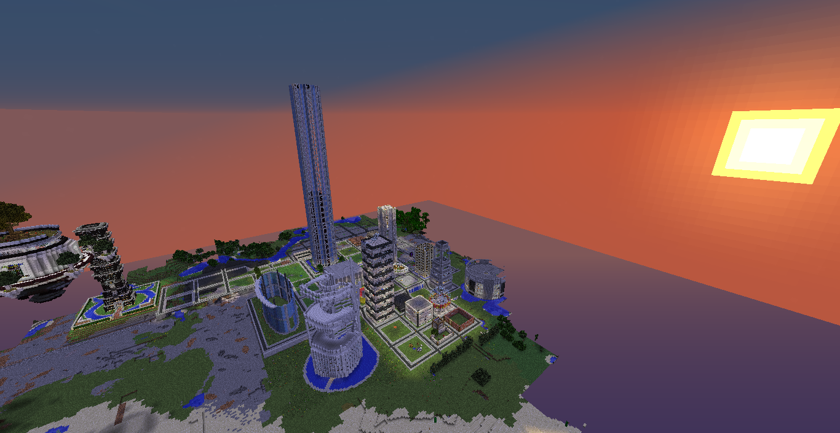
BobCo Tower

Security Complex
One of the most important developments in Arcadia City, although completely unnecessary and unneeded, was an advanced security system. During the planning of the Era6 update, Tonymai1 had encouraged Mephalpha to enable pastebin allowing for computercraft programs to be mass-copied. This would allow for a massive Skandian security system similar to the one they had during Era1. Security wasn’t necessary in PvE however, and with such a large population now in Skandia such a system would only work for a few people, regardless, it was implemented mainly as a show of the future against the past.
In the past during Era1, the security system guarding the base (At a time when PvE griefing was allowed), was hacked and broken into by a traitor from Cassassins which was Skandia’s #1 ally at the time. Using his knowledge he helped an enemy faction to Skandia, Anarchy (Which had been destroyed by Skandia, (See Here: http://dntmain.enjin.com/forum/m/17339906/viewthread/15590125-10-skandian-arcadian-warsconflicts.), break into the city. Although the damage was minimal as two traitors to Skandia were stopped before they could nuke the base, due to LWC being down at the time it led to multiple items being stolen. Following the incident the hope was to develop a new program that would have multiple fail safes should such a disaster ever occur, but without pastebin it was too much work.
Therefore the security complex in Era6, was more symbolic than physical. The project itself was meant to show that Skandia could move on from the past and towards the future. The security system controlled all of the cities lights, doors, monitors, alarms, and practically anything involving Wireless Redstone or Computercraft. All of the computers were kept in a secure building which was built entirely out of Machine Blocks (LWC Protected) so that nobody, even an Arcadian, could break in. Although it was rarely used for anything but for the city lights to turn on and off every day, the security complex showed how far Skandia had progressed from its early days.
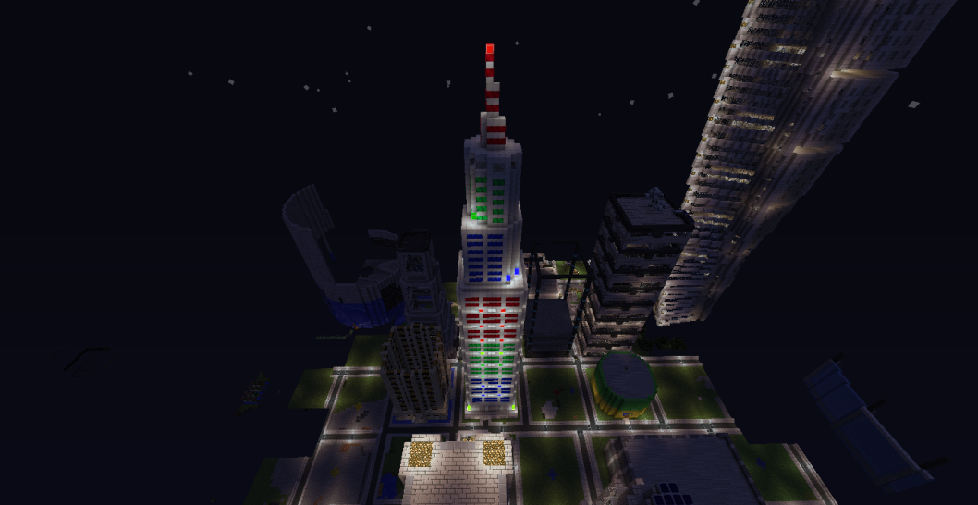

Foreign Investments
Something important to know in order to understand how Arcadia ran and functioned in both Era6 and Era7, plus a major contributing factor to an end to fighting with Riderx26, was a new system that was implemented in Era6 to DNT. Due to a large absence of staff on Tekkit while Arcadia was on Voltz, Mithotysm had gained admin during this period in order to replace Tonymai1 as the Tekkit one. However, Era6 was the first reset where Mithotysm was in a position of power, and used it in order to reform the server believing that “Resets signal change,” altering the ‘status queue’ of resets not changing anything major to Tekkit.
This change was mainly only noticed in two sections in particular: Economics, and Factions. Part of this change was to create a new system for money since it had never found a use on DNT in the past and this lead to MobBounty and MA Arena giving money. However, money having no use with nothing to spend on, led to factions and economics being tied together. Unlike in the past, and on practically every server, anything having to do with factions costs money. This included making a faction, inviting players, names, tags, commands, and most importantly, claims.
Claims would generally not be a problem if it was at a set price, however, claims were increasing at an exponential price from an already ridiculous price. This meant, for large factions like Skandia, that once over 150 claims had been made, every claim was costing over $15,000 to do, and when MobArena barely gave $1000 by the time you died, it was a ridiculously high amount. Therefore, the money needed to claim all this land, generally came from selling plots from the city to certain ‘investors’ for money in return, or to accepting donations. Ironically enough, over half the city claims were paid for using this method, and most of that money, from enemies (See End of Conflict)
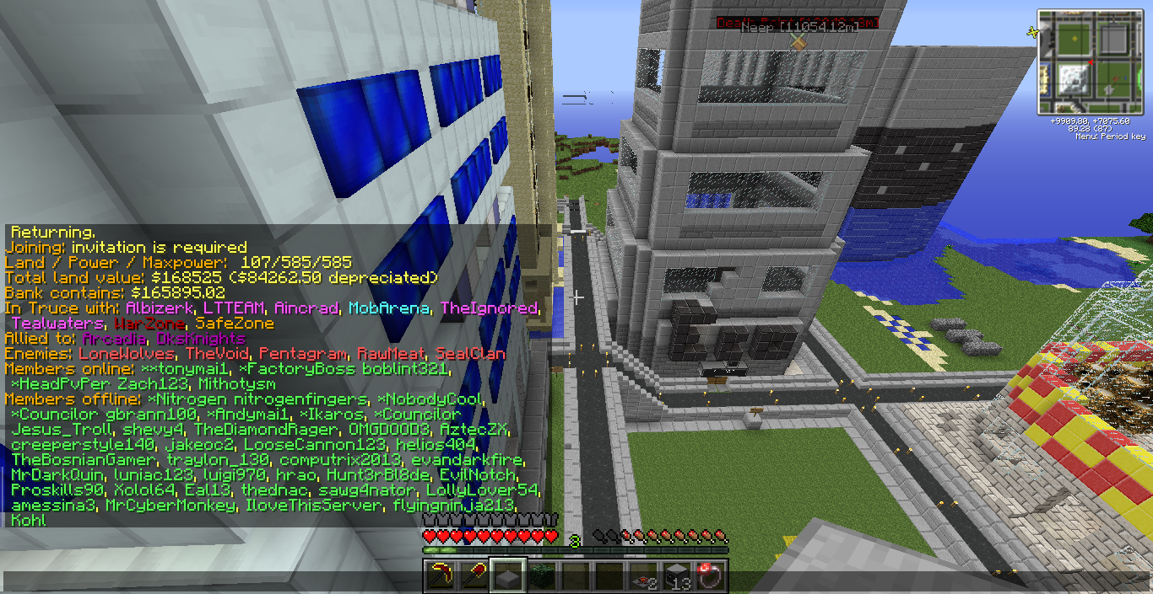
Skandian Data 1

Unity Tower
It should be noted however that the most important building during the time was Unity Tower. Originally built and completed during Era1 following Skandia’s Civil War, it was made to bond the two divided groups of Skandia together. It formed the center most building of the Mushy Island following reconstruction after the Civil War, which although no fighting had ever occurred the simple division and split in Skandia caused the MushySkandian civilization to collapse essentially. Designed by Tonymai1 of Unity and built by both Mushy & Unity Skandians the tower served as a major turning point towards healing the divide in Skandia.
Therefore when Era6 came along, the idea of recreating such a monument to Skandian history which ultimately led to the birth of Arcadia seemed to be a great idea with no downside to it. Indeed, the building served as a major connection point for many of the new Skandians to bond with several of the old Skandians. Ending up almost twice as tall (100Blocks Taller), and being 40x40 instead of 20x20, the tower served as a major icon of the metropolis Arcadia had become.
The building was used as a power plant for the city’s power, an embassy to connect to the Arcadian Territories (Section 3), a laboratory to test new things, a meeting hall for Arcadia, and multiple other things. Most importantly however it was located at the heart of Arcadia and served as a heart of government operations for all but Security which was held at the security tower. Several government factories could be put in the tower if the need ever arose and it could be used as an icon to Arcadia’s Era6 City, something it managed to do until the end of the Era.
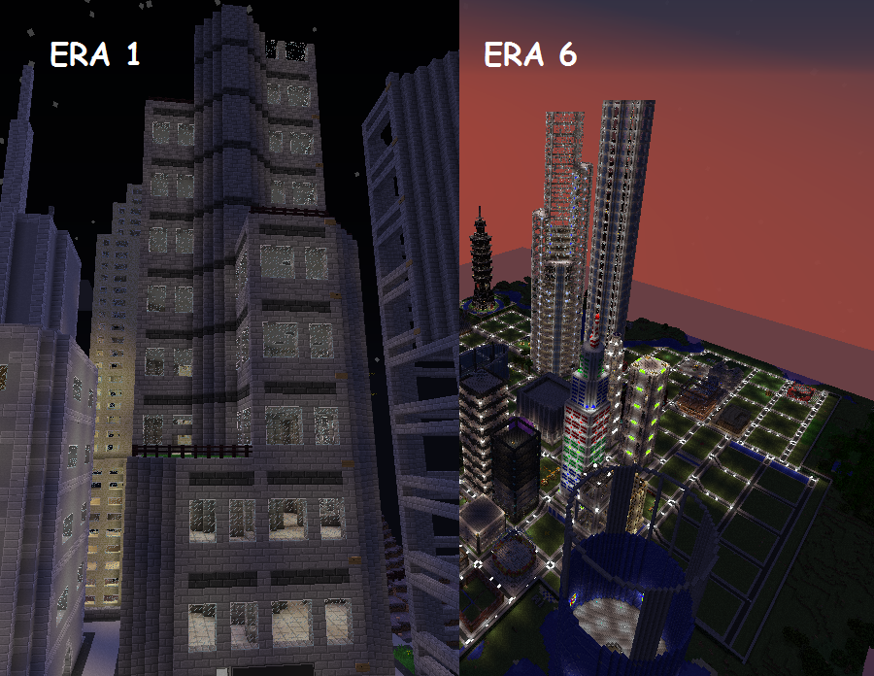

Foreign Conflicts

LoneWolves & Arcadia
Lonewolves was the #1 Faction in Era5 while Arcadia was on Voltz, however unlike Arcadia they were more brutal, and oftentimes, a threat to the alliance. Indeed, their leader neepneep3 had threatened Arcadia’s Director Tonymai1 a few times, and had actually attacked an Arcadian Faction on Voltz days before it shut down. Neepneep3, while on Voltz, attacked & destroyed a NationOfMobsters base causing amessina3 to declare war on Voltz, and for it to ultimately continue into Tekkit.
On Tekkit while Arcadia was setting up for the first time since Era4, neepneep3 made it clear that he intended to make war on Arcadia. After Arcadia made it clear it would not let the attack on NationOfMobsters stand (Arcadian policy requires all Arcadian factions to declare war if one is attacked), neepneep3 would often log on saying “I thought you guys would be discussing how to crush us not talking for fun.” The conflict with Lonewolves was thought more as a nuisance than an actual war however. While neepneep3 tried to publicize it as WW2 for DNT, Arcadia made its stance very clear, “Lonewolves is seen nothing more than a cockroach that continuously needs to be stepped on.”
Indeed, this stance still is kept to this day, with Arcadia referring to the incident as the “Lonewolves Strikes” instead of war. For, to put it in simple context, throughout the entire incident which stretched over a month long, Arcadia would just blow up a Lonewolves base weekly to get neepneep3 to be quiet. It wasn’t until another conflict started that the war on Lonewolves began to ramp up, and this would be the Pentagram Conflict with a long-time enemy to Skandia.
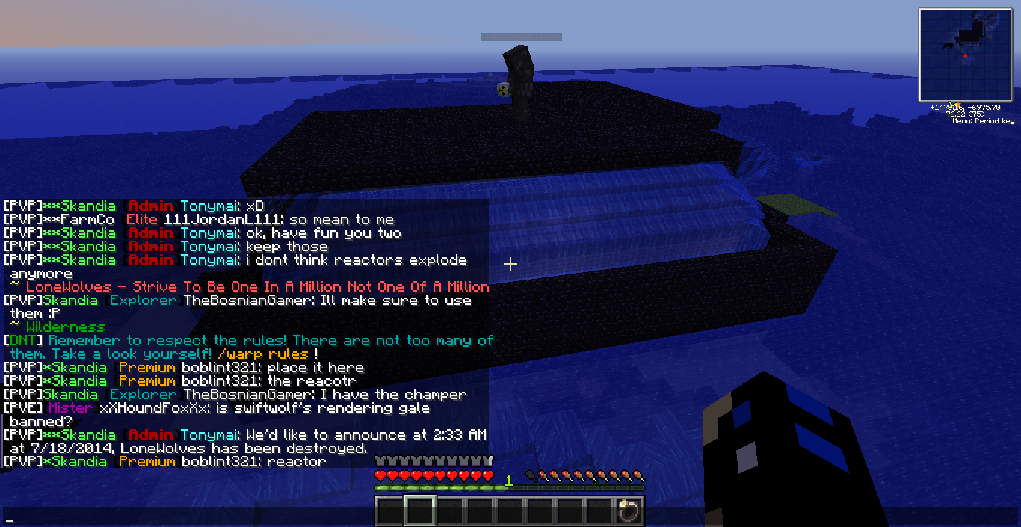

Pentagram Conflict
Ok, I’m sorry, but by Pentagram Conflict I do not mean the return of Malahostias, although that would truly be quite the adventure! However, if anybody recalls from the long lost Era3, http://dntmain.enjin.com/forum/m/17339906/viewthread/13347782-skandian-history-era-3-skandias-golden-age, as a result of the conflict with Malahostias raised the enemy of Riderx26 who claimed to be a “2nd Malahostias.” After months away from Tekkit he had returned, and, sure enough had done something to provoke Skandia.
Unlike the Malahostias conflict however, Riderx26 wasn’t seen as an enemy in that he was destructive, but more a danger to Skandia. This sense of danger certainly increased when he invited Houtex who was a VIP+ from the faction TouchMyPoo, who although is not covered in their own section, was one that was growing fairly large and then collapsed at which Skandia took their member LollyLover54 but refused to take Houtex due to his actions. As a result of this he grew to vehemently [Strongly] hate Skandia, and joined Riderx26 who was a long-time enemy to Skandia. As a result of this Skandia launched a pre-emptive strike against the both of them after receiving information they intended to attack Skandia, whether this ever proved to be true or not was never found, as Houtex was banned for advertising a few days later.
However, as its name as conflict instead of war, this was truly the only attack that ever occurred during the course of the conflict. For the most part, from this point on Skandia fought a proxy war with Riderx26 instead of actual confrontation. This meant instead of fighting each other, it was more of a war between people. You are with him or you are with us, and it continued on this course until Riderx26 joined LoneWolves.
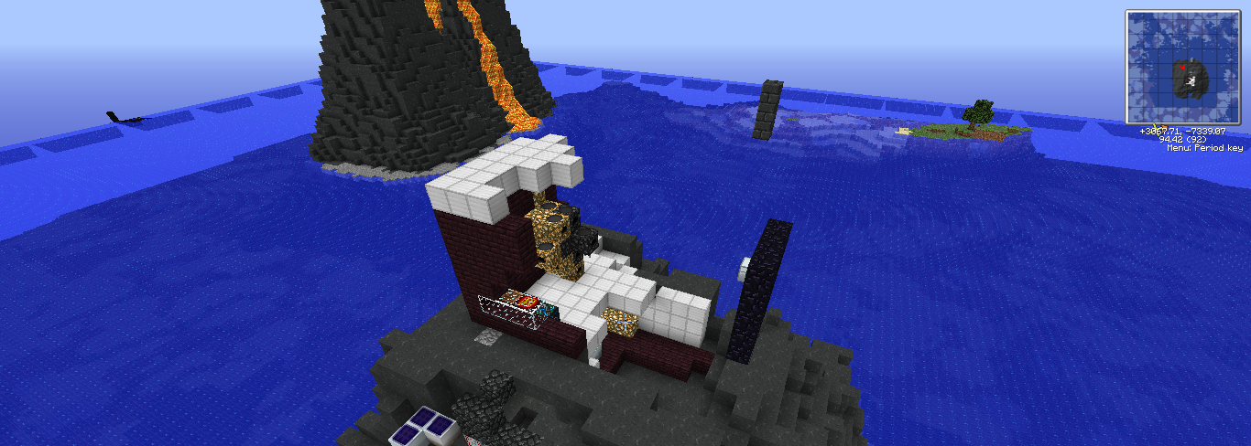

Enemies Combined
Since Riderx26 first showed himself again in Era6, the greatest threat Arcadia believed it would face would be if the two combined together. As such, several tasks were put in place in order to divide the two groups apart, and it appeared to work when both enemied each other for various reasons that Arcadia had set up to occur. However, this ended up in vain when Riderx26 joined LoneWolves in order to gain officer rank and because neep needed a premium in order to raid. At the time of this however, neepneep3 had asked for a truce with Arcadia which was met with the response of “What kind of guy offers a treaty and then invites Skandia's #1 Kill On Sight foe to his faction? This is exactly what our council was worried about. At this stage, your faction has proven it will continue to harbor terrorists to Arcadia.”
Following the incident Lonewolves was attacked and Riderx26 temporarily removed only to rejoin in the future, but it showed that Lonewolves could not be trusted to not invite enemies to Arcadia. One of the major reasons that the conflicts between Lonewolves and Riderx26 never escalated into war was primarily due to the fact that without a premium, neepneep3 couldn’t attack Arcadia back. Similarly, Arcadia didn’t wish to completely destroy Lonewolves due to the fact that in Era4, Arcadia’s aggressive policy made it appear more as an enemy than an ally. Stuck between destroying a threat and maintaining its peaceful goal, Arcadia decided to only attack Lonwolves following aggression to Arcadia. It would not be until August 7 however, that Arcadia fully set out to destroy Lonewolves.
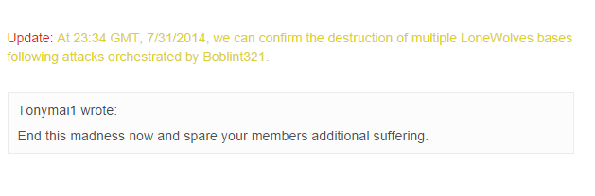

Lonewolves Strikes
On the eve of August 7th, 2014 Lonewolves invited Riderx26, Houtex, FrazeSimple and Tkeonee to their faction. Riderx26 & Houtex formed the core of Pentagram, and had been re-added, FrazeSimple abused a glitch that allowed him to log into Staff’s accounts and wreak havoc on DNT Voltz, and tkeonee was an enemy to Arcadia on Voltz following his argument with 2lostinmusic. The invitation of so many Arcadian enemies, knowingly being done, proved to Arcadia enough to end the Lonewolves threat once and for all. Arcadia gave Lonewolves an ultimatum to leave Lonewolves saying that it would bomb and destroy everything within 24hours.
The threat in itself proved to work immensely as first Riderx, Houtex, and Necsysm (Also Pentagram) left Lonewolves depriving Neepneep3 of all his donator members. Next his normal members began to leave his faction in-game as Arcadia sent mail to all of them, with each and every one stating the same thing over and over, “We don’t want to be part of a war with Arcadia.” Neepneep3 was left with practically no members and Arcadia never attacked all the Lonewolves bases claiming, “LoneWolves has shown and proven it will use its members as a human shield and force them into a situation with no way out. Arcadia has no need or want to force these members into an uncomfortable position where they feel trapped.”
Following the incident, neepneep3 was let in a practically non-existent faction as his main base was attacked and destroyed by Arcadia. The next day on August 9th, 2014 neepneep3 gave the announcement that he was surrendering to Arcadia.
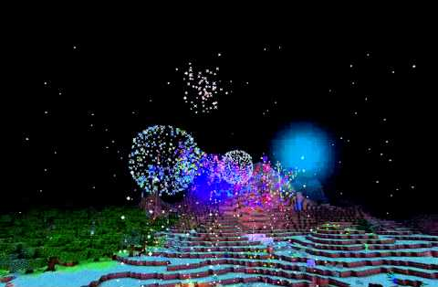

End of Conflict
Following the end to the Lonewolves conflict Arcadia was left with two problems. What to do with Riderx26 and what to do with Tkeonee. Tkeonee served as a spy for Arcadia during the Lonewolves conflict and had been the reason they had gotten so many base cords, but near the end of it he had betrayed Skandia for Lonewolves and as such was no longer considered Skandian. For the most part he was left alone as Arcadia didn’t want more conflict, and, he was later banned for Hacking (bought unban) and then Duping.
Riderx26 was of a more complicated matter. Despite leaving Lonewolves during the conflict, Arcadia and him had been enemies since February (This was August), which meant nearly half a year of fighting. Neither side however wished to truly fight each other, but similarly Arcadia felt it was wrong to do all that fighting in vain. In the end, Riderx26 donated hundreds of thousands to Arcadia to help claim land, and for his own personal plot in the city. Through the contributions the entire city was able to be claimed and council decided that “We’ve been at war with him for a long time, but he’s shown he doesn’t want to fight us and we don’t want to fight him.” It brought an end to the conflict with Pentagram, and opened the door for Riderx26 to rejoin Skandia the next Era. With all the conflicts at end, it brought an end to what Arcadia hoped would be the last war they’d have to fight, unfortunately, it would be just the beginning with what Era7 had in store.

Special Thanks to Riderx26 for offering his views of the conflict.
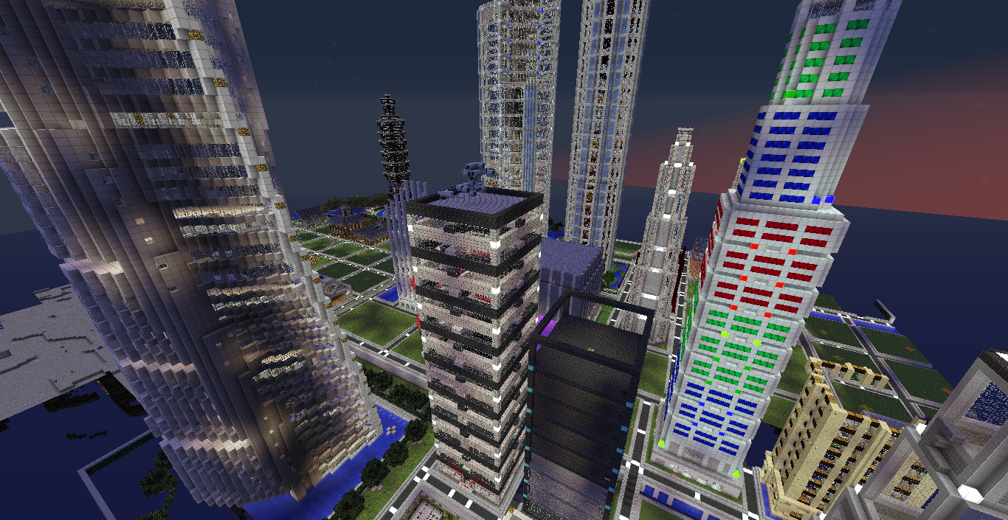

Rebirth of Arcadia

Araluen
Araluen was the first faction to join Arcadia in Era5 on Tekkit. It was originally created by 2lostinmusic with the name Arcadia so that there would be Arcadian Operations on Tekkit again. However, when he was removed from Arcadia the faction was given to _Emorej_ and later in Era6 was renamed to Araluen to avoid confusion. Araluen however was never a very large faction, and did little other than be a part of Arcadia’s council, which at this time wasn’t very established. Araluen however provided the support to prove that there was more than one Arcadian faction out there other than Skandia, and it showed that Arcadia was willing to invite and work with new factions towards joining its alliance.

Return to Skandian Dominance
One of the things that Era5 definitely saw however was a return to Skandia’s power over Tekkit. Skandia was by far the largest Arcadian faction again, and remained that way through Era7 as well, although not at quite a same degree. At its height in Era5, Skandia had a total of 40 members, which made it Skandia’s highest population since the end of Era3. Meanwhile, many of its old members had returned and it was recruiting new ones. Skandia once again became a faction that you would want to be in, and one that more than ever before became to harbor the ideology of what Arcadia was supposed to be, an alliance advocating for peace and prosperity.
Combined with the fact that Skandia was living inside of Arcadia City, it served to show what marvels Skandians had managed to accomplish. Skandian council was thriving, and its members were ultimately living productive lives, and this return of Skandia marked another starting point along with Araluen to revive Arcadia as a stronger entity than it had ever been.

Arcadian Council Reformation
As mentioned above, the Arcadian Council hadn’t been very efficient. Even back in Era4 during Arcadia’s height the council did little as there wasn’t an offline communication network or efficient spot to count votes on. The same went for Skandian Council, where almost everything was done by Tonymai1 because trying to get council’s vote was too hard. Following the Arcadian Coup, one of the most important things Skandia and Arcadia did was establish a skype group for communication, and although it managed to bring Arcadia closer together as an entity, it was also used for the various council chats that Arcadia needed.
With this in mind, Arcadia Council slowly and gradually built its way towards what it was originally meant to be: A group with a director and a council that called all the decisions. The reformation in council was accomplished through the addition of Arcadian factions by the various Arcadian faction leaders already in council, and then gradually calling to vote on more things and to get a more united opinion on what to do. This system was used to establish what to do during both the Riderx and Lonewolves conflicts, and similarly for adding Territories, Factions, and deciding what to do about Arcadia’s future path. As the council system became more successful, the Arcadian factions themselves became more united, and Arcadia in general a better governed entity as multiple opinions were able to be gathered on what to do. Although on most occasions votes were unanimous on what to do, the few occasions where it wasn’t unanimous helped create a more diverse picture of a situation.
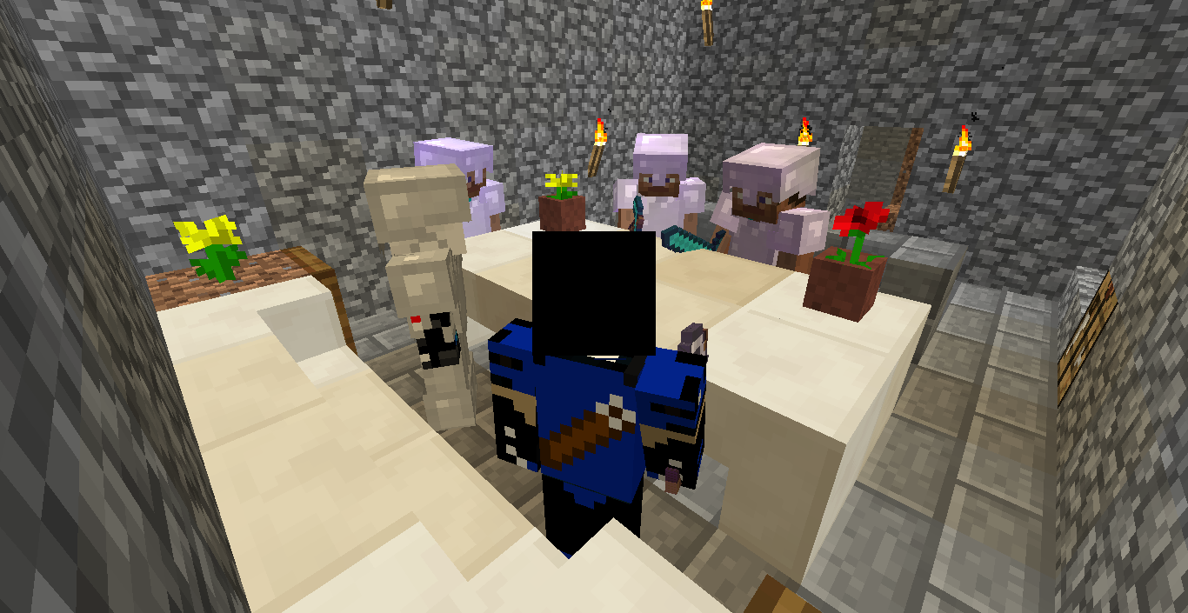

Phoenix
During Era6 the only new faction added to Arcadia was Phoenix. It was a PvE-based faction that had a significant amount of members, and appeared to be talkative and active. They had a base structure almost identical to UnityCastle in Era1, and were still a developing faction. Regardless, Arcadia saw the opportunity that Phoenix represented for the alliance, and similarly Phoenix shared a similar willingness to join Arcadia in return. When the vote was called to add Phoenix to Arcadia therefore, it passed unanimously in under 24hrs, and Phoenix similarly agreed to join Arcadia.
Although the server reset before much could be done between Phoenix and the rest of Arcadia, an effort was made none-the-less to unite Phoenix to Arcadia City and the Arcadian factions. An embassy was built and teleporters attached and powered from both sides for easy access between the two groups. Similarly supplies were shipped into Phoenix and better methods of innovation that Phoenix was not yet using. For instance, instead of BC Pipes there were Redpower pipes, instead of running redstone everywhere Arcadia introduced wireless redstone. The goal was to advance Phoenix so that it would not be behind in technology to the rest of the Arcadian factions, and could participate in the Arcadian economy.
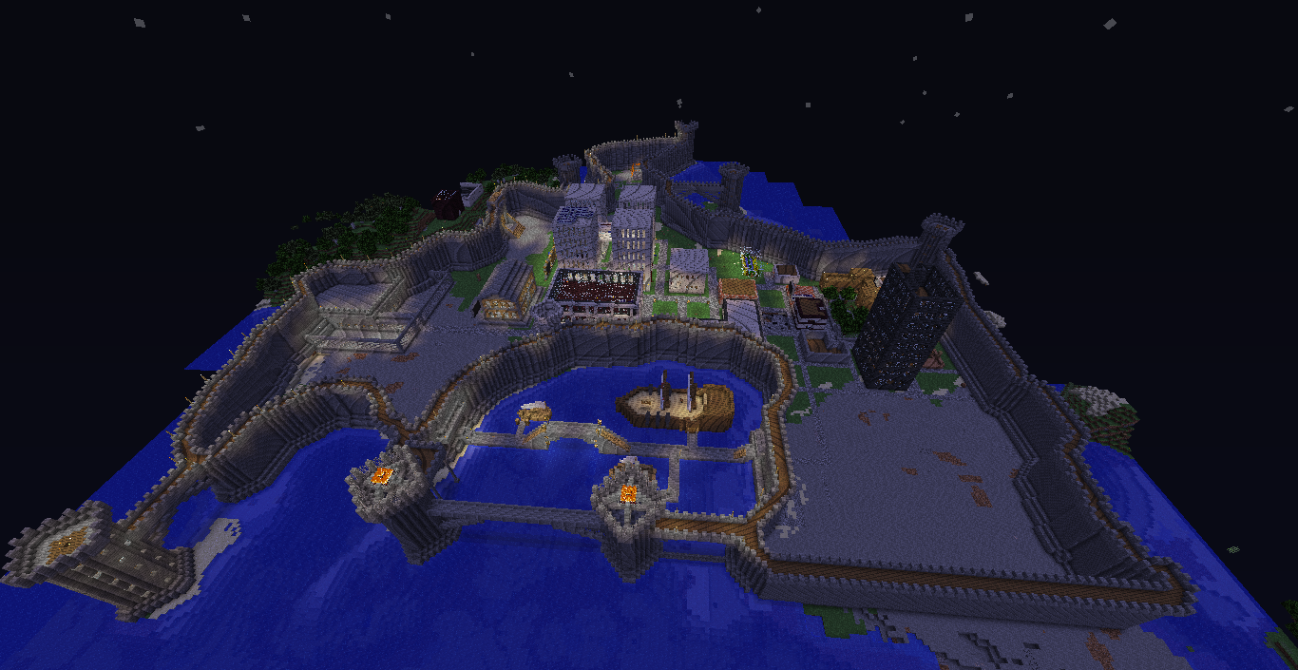

The Hacker that Killed it All
Unfortunately, Arcadia’s time in Era6 came to a sudden and terrible end on August 21, 2014. A hacker had been threatening the server on the forums for several days beforehand, however they were not taken seriously and sure enough hacked the server after their demands were not met. Using a bug in the xAuth plugin, they managed to give themselves the Owner rank and wreak havoc across the server. The hacker banned everyone in staff and as nobody with access to console was on at the time, he was free to destroy the entire server. The hacker simultaneously reset everyone’s ranks, disbanded all the factions, unbanned every player, and randomly /op’d several players as well.
By the time Mephalpha was able to shut down the server, the damage had been done, DNT had been destroyed. Due to the fact that no backup files are kept, for what reason I will never understand, there was no way to undo the damage of the hacking. It would not be for several more weeks before the server would be brought up again with some minor changes, new ranks, and a new system that was supposed to stop any future hackers. However with the banned players list destroyed, Era7 would prove to show that the once banned players were able to make their way on the server again, and with Mithotysm refusing to ban almost all of them without proof of their original ban, they were able to wreak havoc on the server once again. The hacking marked an end to Arcadia’s time on DNT during Era6, yet due to the fact that Arcadia had a chat group; everyone was still able to communicate with each other. While DNT was being repaired, Arcadia went to a Voltz server with its premiums in order to play the mod, the journey, did not go well, and introduced Arcadia to a whole new string of problems it would face in the upcoming Era.
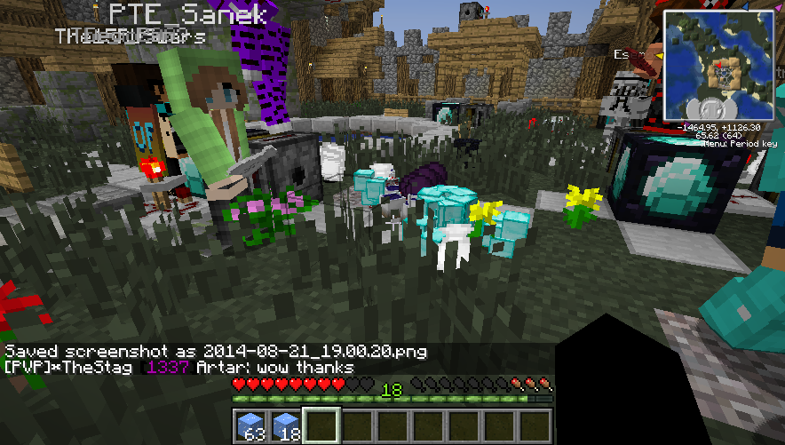
TO BE CONTINUED IN
SKANDIAN HISTORY – ERA 7
Strike from the Past
If Arcadia wishes to progress into the future, it must first conquer its past.

